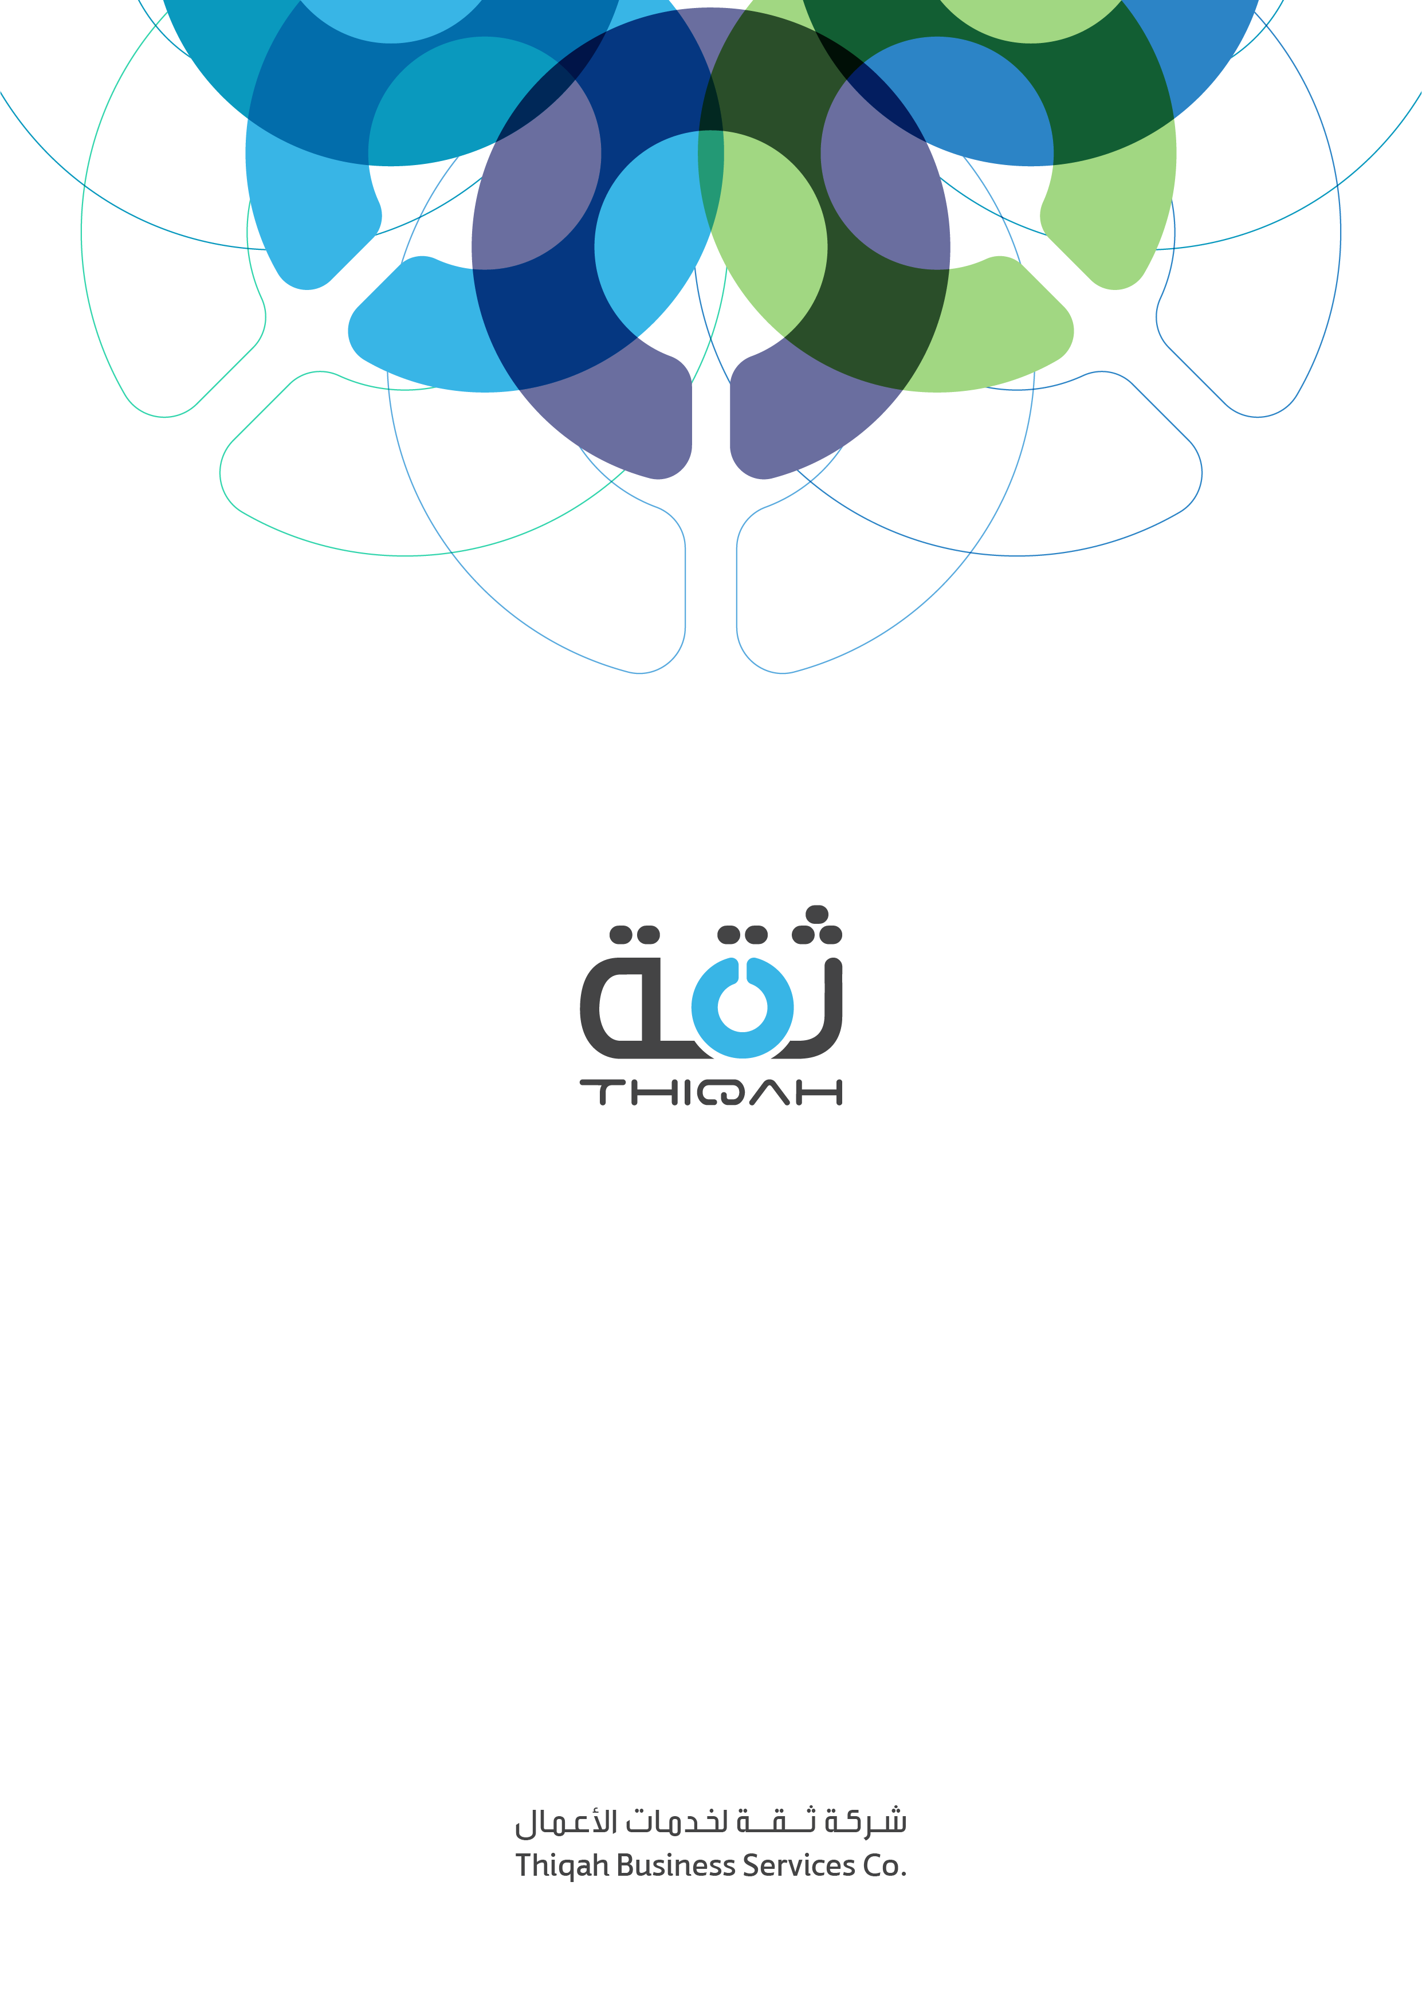

Internal Notification System Guideline

V1.0

Development Department

Version Reviews

|  |  |  |  |  |  |
| --- | --- | --- | --- | --- | --- |
| Version | Date | Status | By | Reviewed By | Remarks |
| 0.1 | 16/02/2022 |  | Eslam Adel |  |  |

Contents

Introduction 3

Prerequisites 3

Database Design 3

Backend 4

Frontend 6

References 8

# Introduction

This document represents a guideline for any development team that wants to implement internal notification system between members.

For example, in Mazad we’ve requirement to push notification from admin to any member(s) (observer, sales agent, assistant) to alert him about something. So, if you’ve such requirements this document will provide step-by-step guidelines to implement real-time pushing notifications using dotnetcore, Angular, and SignalR.

# Prerequisites

* First, we need an azure signalr subscription and set the connection string in the appsetting.json file.
* Add UI application URL in CORS of backend which hosts the hub to allow frontend to connect to the hub.

# Database Design

This is a suggested design you can start with and customize based on the application needs.

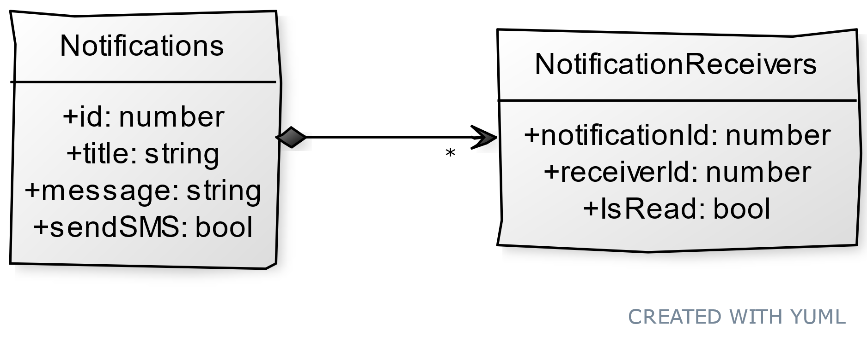

# Backend

1. Install package Microsoft.AspNetCore.SignalR and Microsoft.Azure.SignalR.
2. Create **hub class** in your web host project

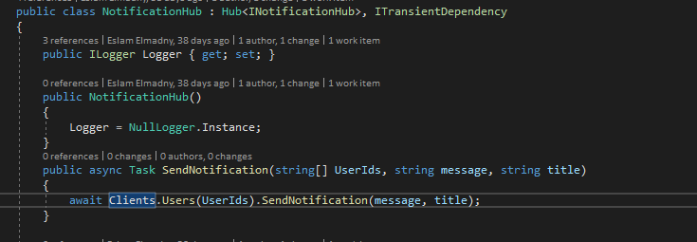

1. Register this hub in **startup** and configure the connection to azure signalr

In Configure methods



In ConfigureServices

services.AddSignalR().AddAzureSignalR(_appConfiguration["AzureSignalRConnectionString"])

1. Map user Id with signalr connection to be able to send messages to specific users. This is so important step to inform the signalr how to relate users with connections and after that, you can just provide the user id and the signalr will be able to identify its connections automatically.

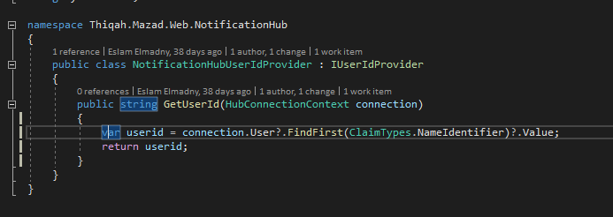

1. Register this provider in configure services method to override the default mapping

services.AddSingleton<IUserIdProvider, NotificationHubUserIdProvider>();

1. Implement send notification function in hub

public async Task SendNotification(string[] UserIds, string message, string title)

{

await _hubContext.Clients.Users(UserIds).SendNotification(message, title);

}

1. Create Api/Controller to consume the hub and push notifications to specific users by passing user id.

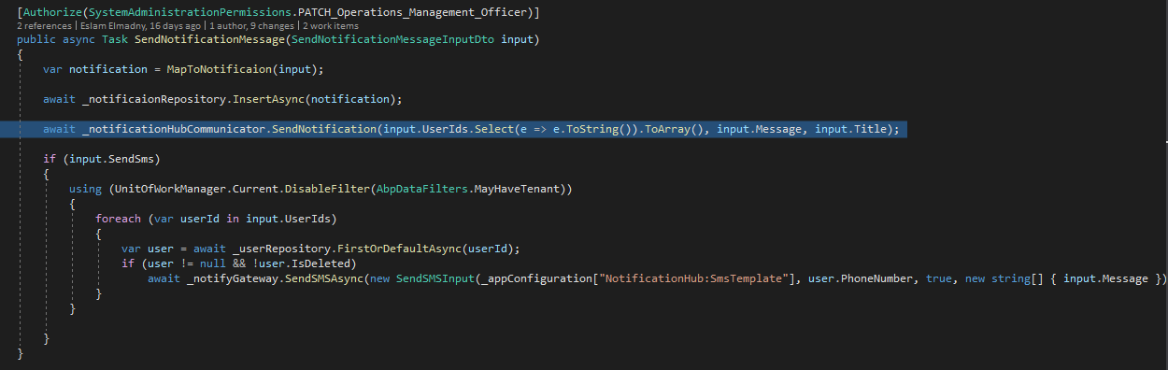

Now you can consume this api from angular project and send required userids to push notifications to.

# Frontend

1. Add Service to encapsulate hub functionality

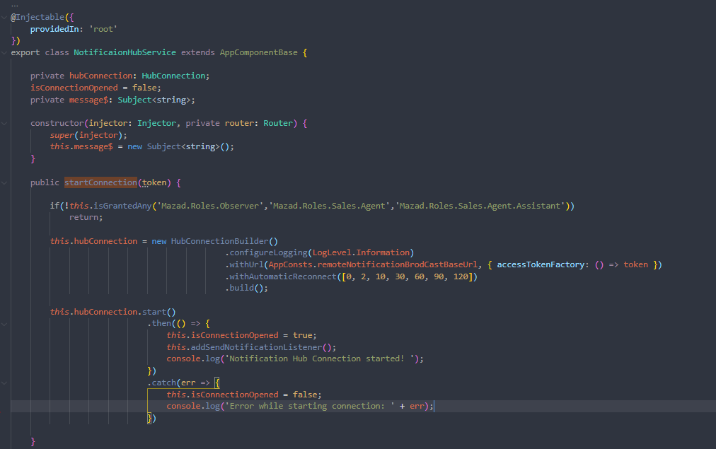

1. In your root component (app.component.ts) inject the ***notificaionHubService*** then in **ngOnInit()** just call startConnection() to connect to the signalr hub once user logged in.

this.notificaionHubService.startConnection(authToken);

1. In your hub service add an event listener as a handler to be able to do all your business requirements after receiving the notification from the admin like opening toast or popup, refresh page, increment notification icon counter … etc.

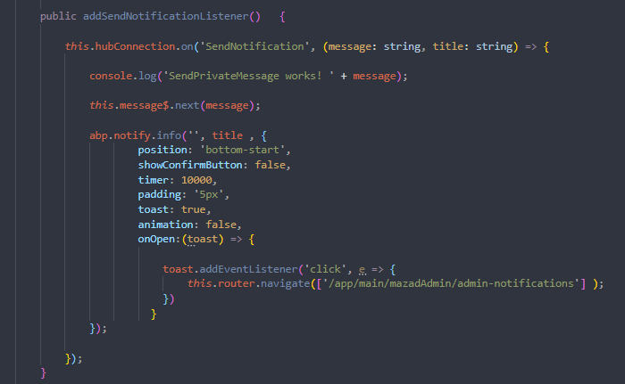

And now as a result, the admin should be able to send messages / push notifications to specific user(s) like the below screen shot.



# References

* [How to connect and scale using azure signalr.](https://docs.microsoft.com/en-us/aspnet/core/signalr/scale?view=aspnetcore-6.0#scale-out)
* [How to map user to connection.](https://docs.microsoft.com/en-us/aspnet/signalr/overview/guide-to-the-api/mapping-users-to-connections#IUserIdProvider)
* [Connecting signalr with angular.](https://dev.to/andrewevans0102/connecting-microsoft-signalr-with-angular-147g)